1. Sorce Code

* Web.php -> Controller
* v_header.php -> View
* v_footer.php -> View
* v_index.php -> View
* v_about.php -> View
* stylebuku.css -> Assets -> css

1. URL

<http://localhost/pustaka_booking_5C/index.php/Web>

<http://localhost/pustaka_booking_5C/index.php/Web/about>

1. Capture Ouput Program

Web (Home)

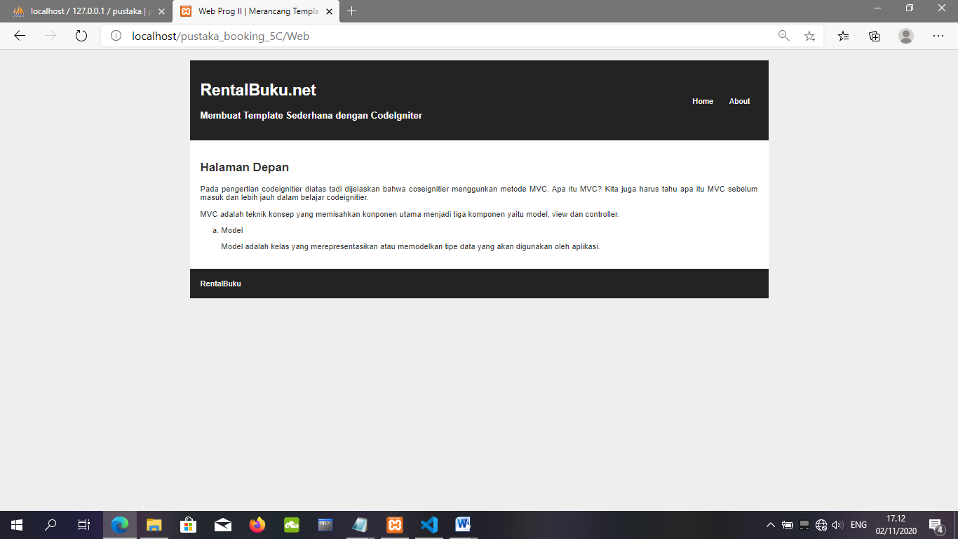

Web (About)

